S. Rushi Keshava Reddy
192472355
C02 – AT1
MLA 0302 - REINFORCEMENT LEARNING

1. Explain how Reinforcement Learning can be applied to optimize delivery routes in
a logistics system. Identify the possible states, actions, rewards, and policy. Discuss
how continuous learning improves efficiency over time.
Explanation
Reinforcement Learning (RL) helps delivery vehicles find the best routes by learning from experience. The agent receives rewards for reaching destinations quickly and penalties for delays or traffic.
RL Components
- States: Current location, traffic condition, fuel level, delivery status.
- Actions: Move left, right, forward, choose another route.
- Rewards:
  - +10 for successful delivery
  - +5 for shortest path
  - -5 for traffic delay
  - -10 for wrong route
- Policy: Select the route with the highest expected reward.
Continuous Learning
The system learns from previous trips and adapts to changing traffic conditions, reducing travel time and fuel consumption.
CODE:
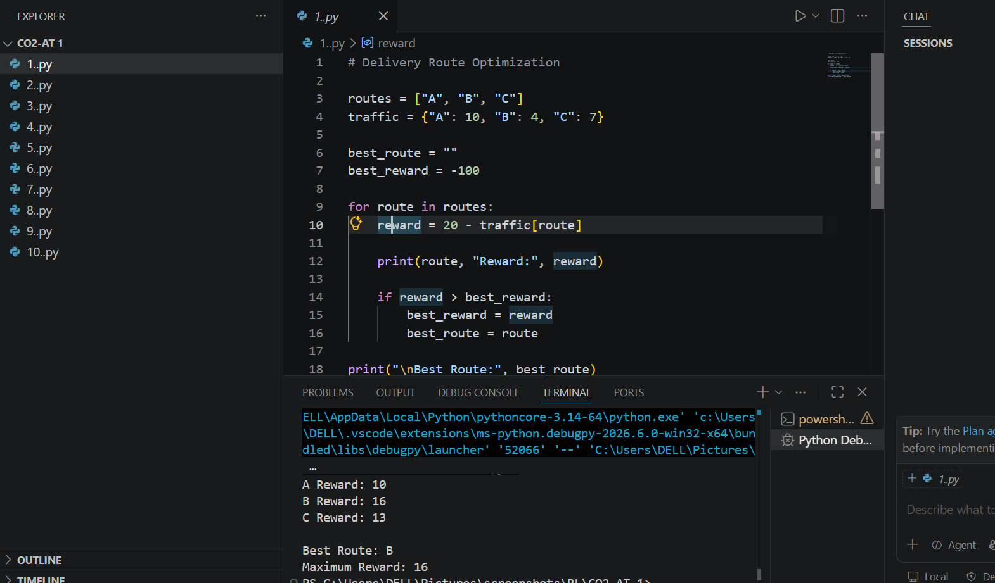

2. Apply Reinforcement Learning concepts to a fraud detection system in fintech.
Define the state space, action space, and reward mechanism. Explain how
exploration strategies improve detection accuracy.

Question Explanation
A fraud detection system is used by banks and online payment applications such as Google Pay, PhonePe, and PayPal to identify fraudulent transactions.
Every time a transaction is made, the Reinforcement Learning (RL) agent:
- Observes the transaction details.
- Decides whether to approve or block the transaction.
- Receives a reward based on whether the decision was correct.
- Learns from previous transactions to improve future decisions.
CODE:
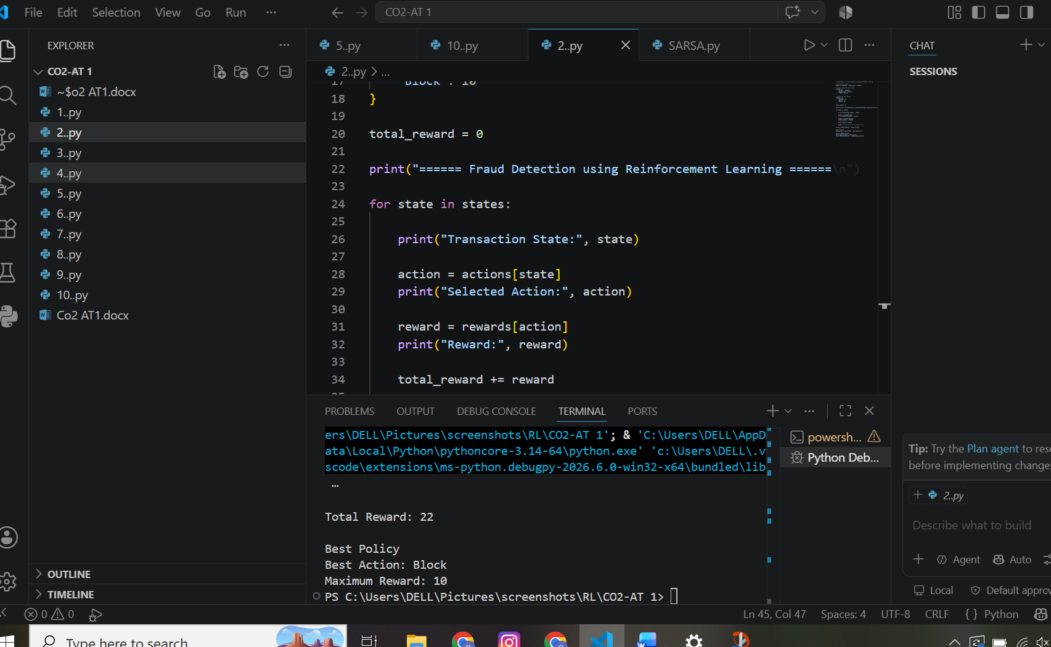
3. Illustrate how Reinforcement Learning is used in a streaming platform for content
recommendation. Discuss the impact of delayed rewards, user feedback, and
changing preferences on learning performance.

Explanation
Streaming platforms use RL to recommend movies or songs based on user interests.
Key Factors
Delayed Rewards
The reward is received later when users watch, like, or complete the content.
User Feedback
- Likes
- Ratings
- Watch time
- Skipping content
These help improve recommendations.
Changing Preferences
User interests change over time. RL continuously updates recommendations based on new behavior.
CODE:
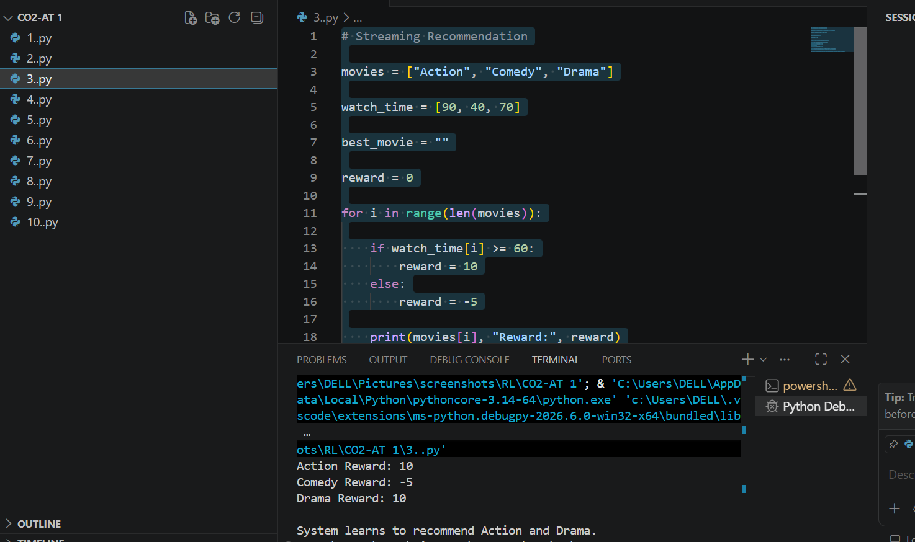
4. Evaluate the effectiveness of Reinforcement Learning in predictive maintenance
compared to traditional rule-based approaches. Discuss risks and reliability concerns
in industrial environments.

Explanation
RL predicts machine failures before they happen and schedules maintenance at the right time.
RL vs Rule-Based System
Reinforcement Learning | Rule-Based System
Learns automatically | Uses fixed rules
Improves with experience | Does not learn
Adapts to new situations | Limited flexibility
Reduces maintenance cost | May miss unexpected failures
Risks
- Incorrect learning may cause failures.
- Requires large amounts of data.
- Safety is important in industries.
CODE:
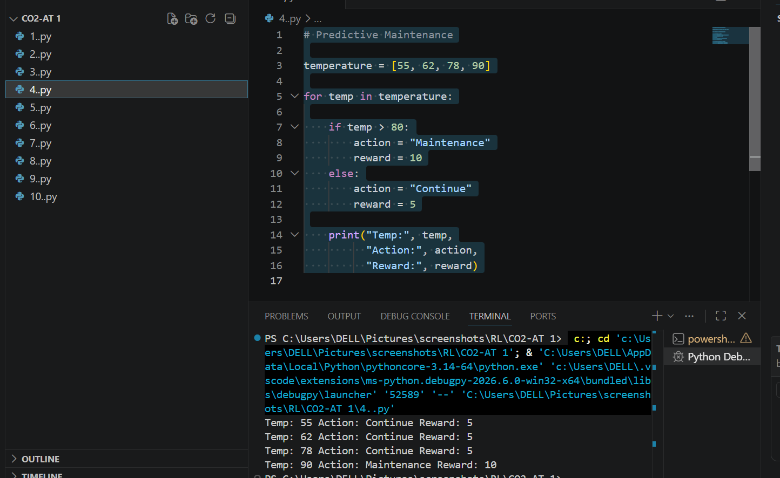

5. Analyze how Reinforcement Learning can be used to optimize transportation
systems such as bus scheduling or route allocation. Define states, actions, and
rewards, and discuss how real-time data improves performance.

Explanation
It is to explain how Reinforcement Learning (RL) can improve a transportation system, such as bus scheduling or route allocation.
Instead of following fixed routes or schedules, an RL agent learns from experience. It observes the current traffic conditions, takes an action, receives a reward or penalty, and gradually learns the best decision.
Example
Imagine a city bus has to travel from Bus Station to Railway Station.
- If the road has low traffic, the bus follows the normal route.
- If there is medium traffic, the bus adjusts its schedule.
- If there is heavy traffic, the bus takes an alternate route.
If the bus reaches the destination on time, the RL agent receives a positive reward. If the bus is delayed due to traffic, it receives a lower reward or penalty. After many trips, the RL agent learns which route is best under different traffic conditions.
CODE:
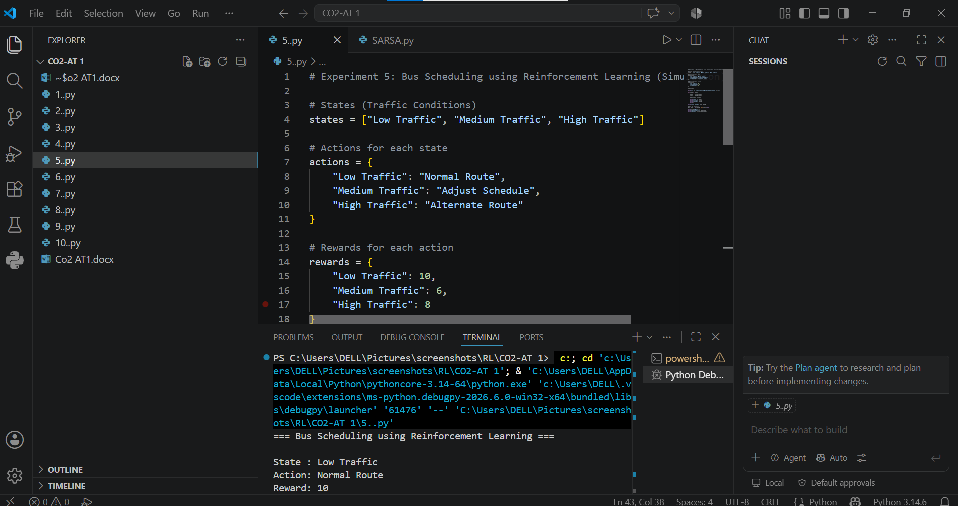
6. Apply Reinforcement Learning to dynamic pricing in e-commerce. Define the state
space, action space, and reward function. Discuss challenges in balancing
exploration and exploitation.

Explanation
RL changes product prices automatically based on demand and customer behavior.
RL Components
- State Space: Demand, stock level, competitor prices.
- Action Space: Increase price, decrease price, keep price same.
- Reward Function:
  - Higher profit → Positive reward
  - Lower sales → Negative reward
Exploration vs Exploitation
- Exploration: Try new prices to discover better profits.
- Exploitation: Use the best-performing price learned earlier.
Balancing both is important for maximum revenue.
CODE:
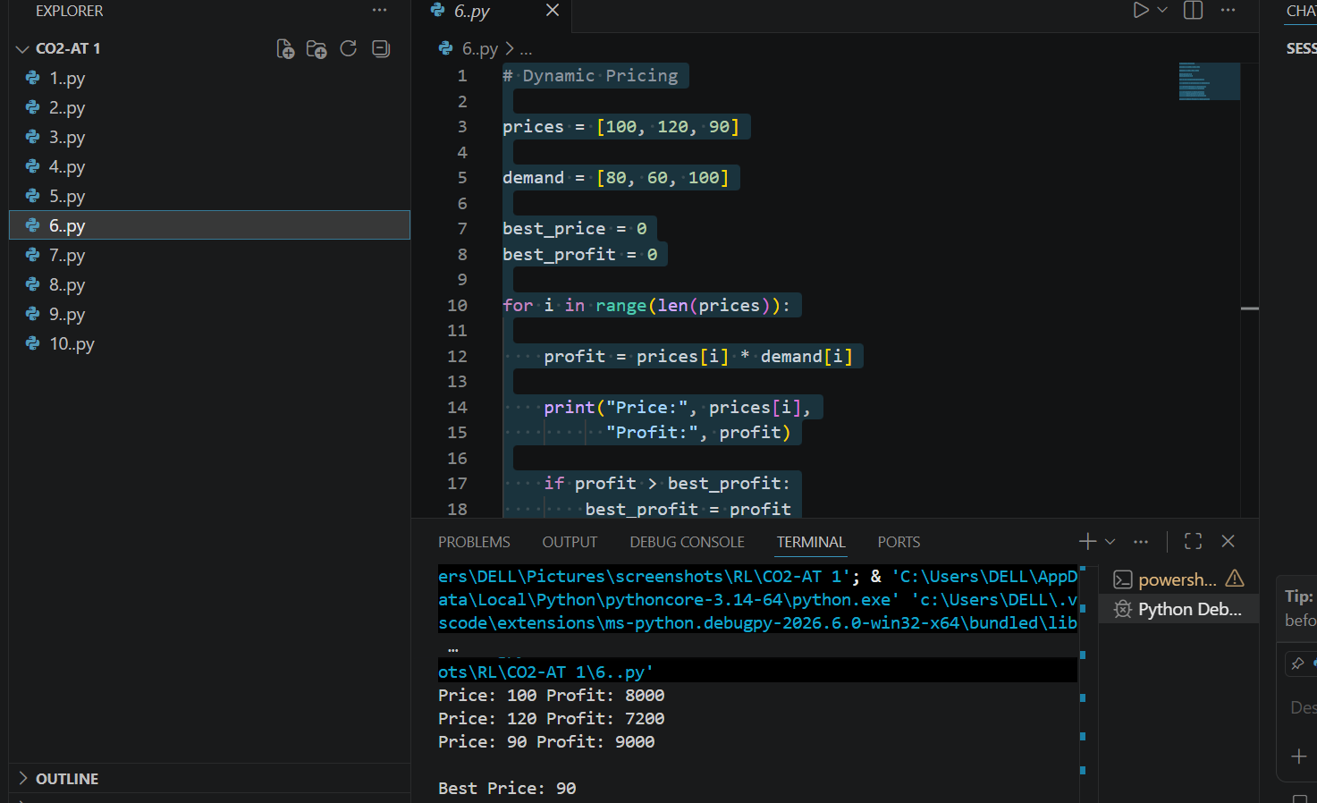
7. Illustrate the use of Reinforcement Learning in smart city waste management
systems. Identify the MDP components and discuss how continuous updates improve
operational efficiency.

Explanation
RL helps optimize garbage collection routes and schedules.
MDP Components
- States: Bin fill level, truck location, traffic.
- Actions: Choose next bin, change route, schedule pickup.
- Rewards:
  - +10 for emptying full bins
  - +5 for shortest route
  - -10 for missed pickups
- Policy: Choose the most efficient collection plan.
- Environment: City roads, bins, traffic.
Continuous Updates
The system continuously updates routes based on real-time bin sensor data, reducing fuel usage and improving cleanliness.
CODE:
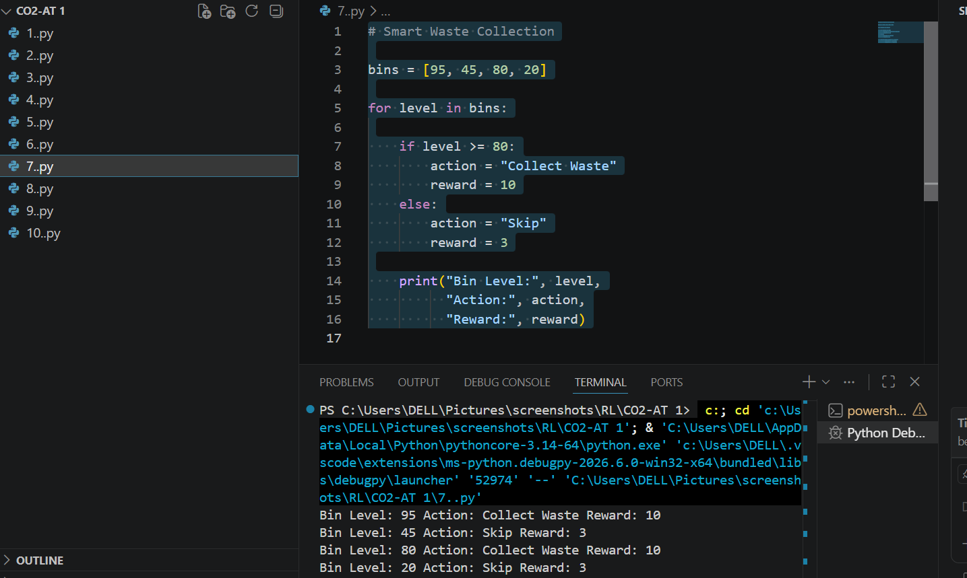
8. Evaluate how Reinforcement Learning can be used in network bandwidth
allocation in telecommunications. Define states, actions, and rewards, and examine
how the system adapts to dynamic conditions.

Explanation
RL distributes internet bandwidth efficiently among users.
RL Components
- States: Current bandwidth usage, number of users, network congestion.
- Actions: Increase, decrease, or redistribute bandwidth.
- Rewards:
  - +10 for smooth communication
  - +5 for efficient bandwidth usage
  - -10 for congestion
Dynamic Adaptation
The agent continuously adjusts bandwidth allocation according to changing network traffic.
CODE:
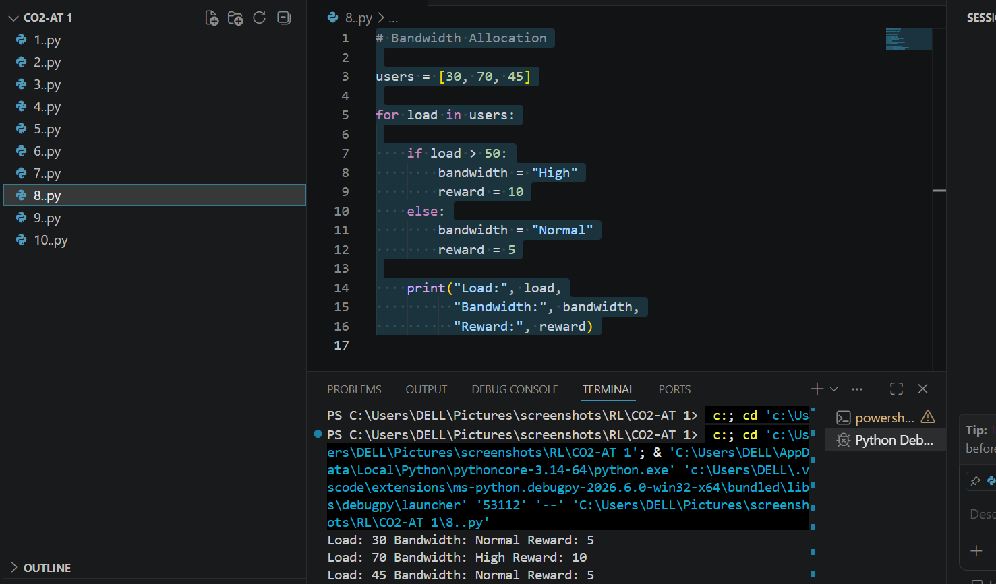
9. Analyze the application of Reinforcement Learning in portfolio management in
finance. Discuss advantages over traditional models and challenges such as risk and
delayed rewards.

Explanation
RL helps investors decide how to allocate money among different investments.
Advantages
- Learns from changing market conditions.
- Adjusts investment strategies automatically.
- Can maximize long-term returns.
Challenges
- Stock market is unpredictable.
- Rewards are delayed because profits appear later.
- High risk due to market fluctuations.
CODE:
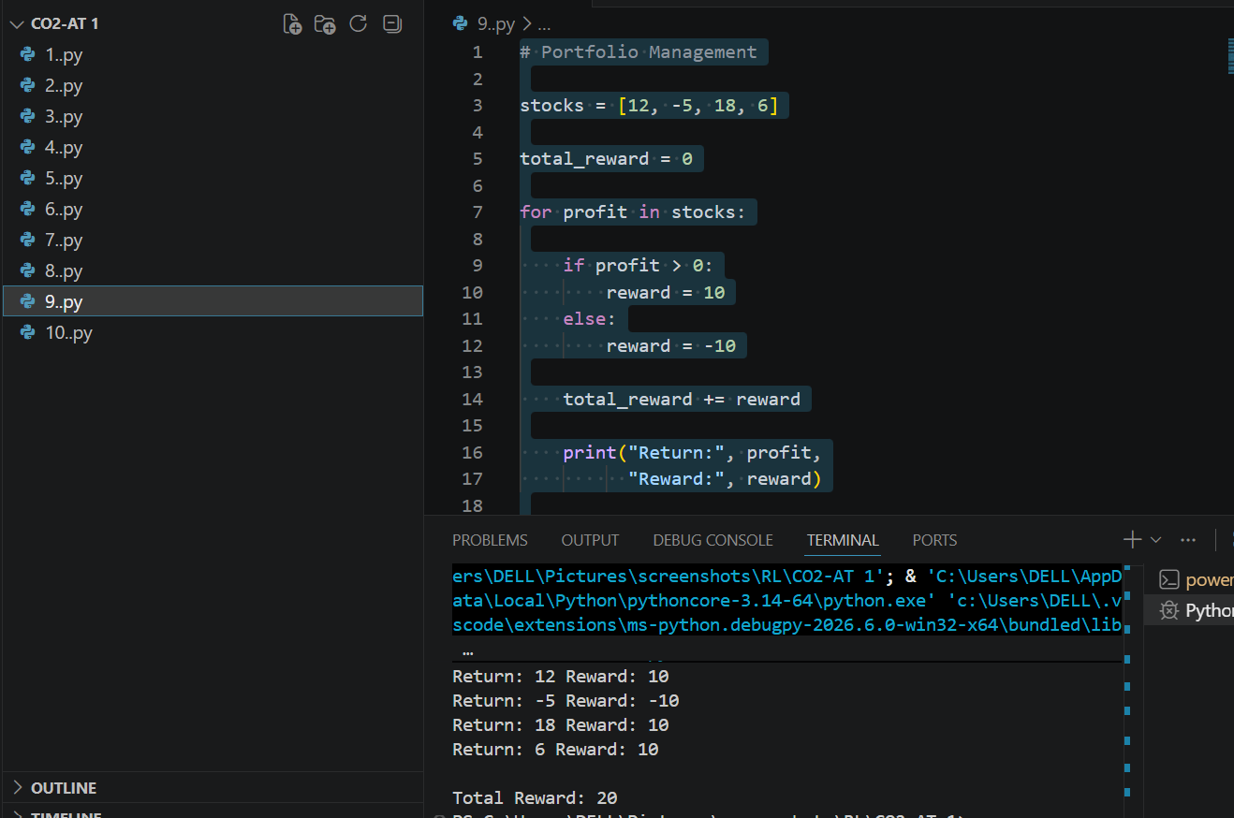

10. Justify the use of Reinforcement Learning in renewable energy management
systems. Define the RL framework components and discuss the impact of
environmental uncertainty on decision-making.

Explanation
- State: The current weather condition (Sunny, Cloudy, or Windy).
- Action: The decision taken by the RL agent, such as supplying solar power, using stored battery energy, or supplying wind power.
- Reward: A score that indicates how effective the action is. Higher rewards mean better energy management.
- Policy: The strategy of selecting the action with the highest reward. In this example, when the weather is Sunny, supplying solar power gives the highest reward, so it is considered the best policy.
CODE:
